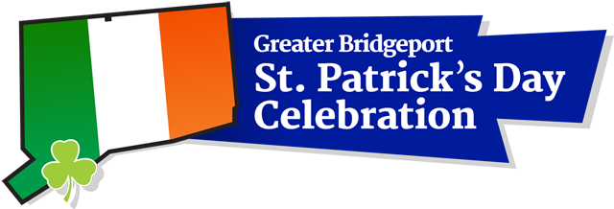

2022 Mr. and Miss Shamrock Contest Application
STUDENT INFORMATION PARENT INFORMATION
Name _____________________________ _______________________________
Home Address (city and zip too)__________________________________________________
Cell phone __________________________
Parent’s Cell__________________________
e-mail_______________________________________________________________________
Parent’s Email _______________________________
School attending ______________________________ Grade________________________
Birthday______________________________________

Please answer the following questions. (The judges may ask you to elaborate on your answers as part of your personal interview) Your focus is on your Irish heritage, not your academic achievements. Limit answers to 200 words each.
- Why would you like to be Mr. or Miss Shamrock 2022?
- What has been your involvement in the Bridgeport St. Patrick’s Day Parade in the past?
- What are some of the Irish traditions with which you are familiar?
- What aspect of Irish history interests you the most? Why?
- Please list your extra-curricular activities including community involvement.
- List your hobbies and interests.

Please return your completed application by December 15, 2021 to Colleen Sargent Murphy at ShamrockCT@yahoo.com. You may reach Colleen by phone at 203-258-7041 if you have any further questions. Thank you.
Fall 2021

Dear High School Seniors,

The Greater Bridgeport St. Patrick’s Day Celebration Committee will host a 2022 Mr. and Miss Shamrock Scholarship Program in conjunction with our annual St. Patrick’s Day Parade and Celebration. Applicants are required to complete the application by the deadline and will be interviewed by an independent panel of judges. They will select the winners based upon their knowledge of family traditions, Irish history, their involvement in the parade, the community and their interests and activities.

The winners will each receive a $5,000 scholarship award for future educational endeavors. Runners-up will also be selected for Mr. and Miss Shamrock. Each runner-up will also receive a $2,500 monetary scholarship award and will participate in all the events with the Mr. and Miss Shamrock throughout 2022. Our website is www.stpatricksdaybridgeport.com.

Interviews for the scholarship program will be held in late December or early January. The committee encourages all High School Seniors to complete the application and return via email no later than Wedneday, December 15, 2021. ONLY HIGH SCHOOL SENIORS ARE ELIGIBLE TO APPLY.

This is an excellent opportunity for High School Seniors in the Greater Bridgeport area. The committee looks forward to your participation in 2022, which also marks the 40th Greater Bridgeport St. Patrick’s Day Parade Celebration.

Sincerely,
Colleen Sargent Murphy
ShamrockCT@yahoo.com
203-258-7041

