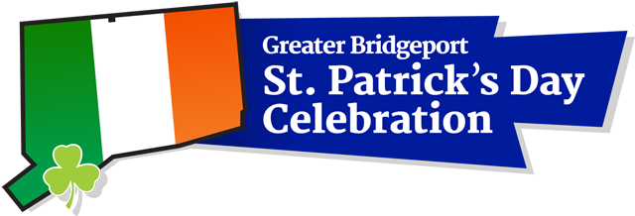

2020 Mr. and Miss Shamrock Contest Application
STUDENT INFORMATION PARENT INFORMATION
Name _____________________________ _______________________________
Home Address (city and zip too)________________________________________________________
Home Telephone_______________________________________________________
Cell phone __________________________ Parent’s Cell______________________________
e-mail_______________________________ Parent’s Email _______________________________
School attending ______________________________ Grade________________________
Birthday______________________________________

Please answer the following questions. (The judges may ask you to elaborate on your answers as part of your personal interview) Your focus is on your Irish heritage, not your academic achievements. Limit answers to 200 words.
- Why would you like to be Mr. or Miss Shamrock 2019?
- What has been your involvement in the Bridgeport St. Patrick’s Day Parade in the past?
- What are some of the Irish traditions with which you are familiar?
- What aspect of Irish history interests you the most? Why?
- Please list your extra-curricular activities including community involvement.
- List your hobbies and interests.

Please return your completed application by December 1, 2019 to Colleen Sargent Murphy at ShamrockCT@yahoo.com. You may reach Colleen by phone at 203-258-7041 if you have any further questions. Thank you.

Dear High School Seniors,

The Greater Bridgeport St. Patrick’s Day Celebration Committee will host a 2020 Mr. and Miss Shamrock Contest and Dance in conjunction with our annual St. Patrick’s Day Parade and Celebration. Contestants will be interviewed by an independent panel of judges. They will select the winners based upon their knowledge of family traditions, Irish history, their involvement in the parade, the community and their interests and activities.

The winners will each receive a $4,000 scholarship award for future educational endeavors. Runners-up will also be selected for Mr. and Miss Shamrock. Each runner-up will also receive a $2,000 monetary scholarship award and will participate in all the events with the Mr. and Miss Shamrock throughout 2020.

Mr. and Miss Shamrock will be an important role for the Committee’s St. Patrick’s Day events. The highlight of this event will be the St. Patrick’s Day Parade in downtown Bridgeport on Tuesday, March 17, 2019. Our website is www.stpatricksdaybridgeport.com.

The contest will take place on Saturday, December 14, 2019 at the Gaelic American Club, located at 74 Beach Road, Fairfield, CT. The committee encourages all High School Seniors to complete the application and return it to the address shown below no later than Sunday, December 1, 2019. ONLY HIGH SCHOOL SENIORS ARE ELIGIBLE TO APPLY. Judging for the contest will be held on December 14, 2019, the night of the dance in the afternoon (Exact Time-TBD) at the GAC. All contestants will be introduced and winners will be announced that evening. In the event of inclement weather, the contest and dance will be held on Sunday, December 15, 2019.

The Mr. and Miss Shamrock Dance will be held from 6:00-9:00pm. Tickets will be $20 per person. All contestants will be admitted to this event free of charge. Anyone accompanying them who wishes to attend the dance must purchase a ticket. (Teens will be $10 and kids 13 and under will be free). Please contact the undersigned to make reservations and to purchase tickets.

This is an excellent opportunity for High School Seniors in the Greater Bridgeport area. The committee looks forward to your participation in 2020, which also marks the 38th Anniversary of the Greater Bridgeport St. Patrick’s Day Parade Celebration.

Sincerely,
Colleen Sargent Murphy
ShamrockCT@yahoo.com
203-258-7041

